January 2022

Initial Risk Assessment

Audit of UNESCO Teheran Office

**Declaration of non-conflict of interest: The audit team has read and understood the Code of Ethics for Internal Auditors. The audit team agrees to adhere to the Code of Ethics and, should the audit team have any questions or encounter any circumstances potentially impairing the adherence to the Code such as conflict of interest, the audit team will immediately bring them to the attention of their supervisor or to the IOS Director.**

During the preparation of IRA, please comply with the IIA Standard 1220.A1. – Internal auditors must exercise due professional care by considering the:

* Extent of work needed to achieve the engagement’s objectives;
* Relative complexity, materiality, or significance of matters to which assurance procedures are applied;
* Adequacy and effectiveness of governance, risk management, and control processes;
* Probability of significant errors, fraud, or noncompliance; and
* Cost of assurance in relation to potential benefits.

**1** **Country Overview** 3

**2** **UN Agencies in the country** 4

2.1 Overview of UN agencies in the country where the FO is located 4

**3** **Control Environment** 5

3.1 Overview of the audited area 5

3.2 Leadership composition and organigram 6

3.3 Accountability framework and delegation of authority 7

3.4 Ethical conduct 9

**4** **Risk Management** 11

4.1 Results of the Control Self-Assessment 11

4.2 Medium and high residual risks from the risk register as of 2018 11

4.3 Medium and high residual risks from the fraud risk assessment. 12

**5** **Control Activities** 13

5.1 Flowcharts with clearly marked key controls and potential risks (received from the AO) 13

5.2 Key policies and documented procedures relevant to the audited area 16

5.3 IT support and key systems 16

5.4 Operational budget of the sector, field office, programme, institute and breakdown 17

5.5 Other statistical information e.g., from DUO, SAP 19

**6** **Information and Communication** 20

**7** **Prior Reports by Assurance Providers** 20

**8** **Donor requirements** 21

**9** **Preliminary Control Weaknesses** 22

**10** **Report - Audit Rationale, Scope and Objective** 22

**11** **Report - Background** 25

**12** **Annex 1 – Risk Matrix and Work Programme** 26

Engagement Terms of Reference (Title of the Audit) 27

|  |
| --- |
| **Country Overview** |

****Overview of country where the FO is located****

* Country’s population
* Iran’s is a lower middle-income country in Middle East region with a population of 83.9 Million. (Source: <https://data.worldbank.org/country/iran-islamic-rep>; <https://databank.worldbank.org/views/reports/reportwidget.aspx?Report_Name=CountryProfile&Id=b450fd57&tbar=y&dd=y&inf=n&zm=n&country=IRN>)
* Life expectancy, literacy rate, any other relevant ratio
* The life expectancy is 77 years. Its GDP per capita is $ 3640 and its GDP is $ 258 Million.

(Source: <http://uis.unesco.org/en/country/ir>). Iran has a young literate population while older population is less literate.

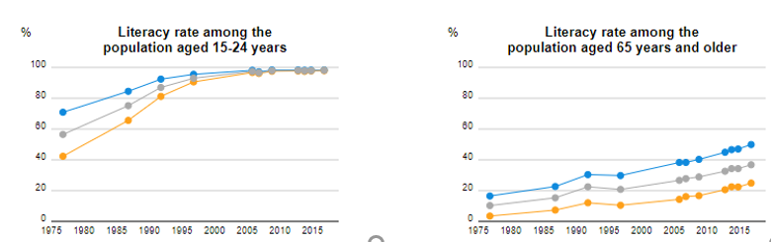

* Main challenges

*Economy*

* Iran’s economy is characterized by its hydrocarbon, agricultural, and service sectors, as well as a noticeable state presence in the manufacturing and financial services. Iran ranks second in the world for natural gas reserves and fourth for proven crude oil reserves.

*Sanctions*

* Iran had been disconnected from the worldwide Interbank Financial Telecommunication (SWIFT) between 2012 and 2016 pursuant to international and multilateral action to intensify financial sanctions. Due to primary sanctions, transactions of U.S. banks with Iran or transactions in U.S. dollars with Iran both remain prohibited.
* Since May 2018, Iran is subject to US sanctions. These sanctions, which include third party sanctions on international banking transactions, have led to a drastic reduction in Iranian oil exports, strong devaluation of the national currency, increased inflation, and economic recession. Despite these difficulties, Iran appears to be weathering the economic storm, thanks in part to its foreign reserves, low level of foreign debt, pragmatic macro-economic strategies, and high level of social services.
* UNESCO’s local bank is Tejarat. The bank is subject to US Sanctions imposed by Office of Foreign Assets Control (OFAC) following the Joint Plan of Action (JPA).
* Finally, Iran like most countries is also grappling with the impact of COVID-19 crisis. This has affected production of goods and services thereby affecting household income. This has also exasperated challenges for UN agencies like UNESCO to conduct business.

|  |
| --- |
| **UN Agencies in the country** |

## Overview of UN agencies in the country where the FO is located

Iran was one of the founding signatories to the UN charter in 1945. There are 18 UN agencies resided in Iran comprising the UNCT. Like most countries around the world, the UNDP Resident Representative is also the UN Resident Coordinator (UNRC), representing the UN system in Iran. As the chair of the UN Country Team (a team comprising the heads of UN agencies), the Resident Coordinator provides overall leadership for the United Nations strategic initiatives and the operational framework for development in the I.R. Iran.

The office of the Resident Coordinator aims to bring together the different United Nations agencies to improve the efficiency and effectiveness of operational activities at the country level. Working closely with national governments, Resident Coordinators and UN Country Teams (UNCTs) advocate the interests and mandate of the United Nations drawing on the support and guidance of the entire United Nations family.

* UN Agencies based in the country, their main operation activities, number of staff

There are currently 18 UN agencies, funds, and programmes with operating offices in Iran.

UN agencies and entities in Iran:

* [FAO](https://www.un.org.ir/resources/factsheets/item/3368-fao-en)
* [IOM](https://www.un.org.ir/resources/factsheets/item/3370-iom-en)
* [UNAIDS](https://www.un.org.ir/resources/factsheets/item/3372-unaids-en)
* [UNAMA](https://www.un.org.ir/resources/factsheets/item/3374-unama-en)
* [UNAMI](https://www.un.org.ir/resources/factsheets/item/3376-unami-en)
* [UNDP](https://www.un.org.ir/resources/factsheets/item/3378-undp-en)
* [UNDSS](https://www.un.org.ir/resources/factsheets/item/3380-undss-en)
* [UNESCO](https://www.un.org.ir/resources/factsheets/item/3382-unesco-en)
* [UNFPA](https://www.un.org.ir/resources/factsheets/item/3384-unfpa-en)
* [UNHABITAT](https://www.un.org.ir/resources/factsheets/item/3386-un-habitat-en)
* [UNHCR](https://www.un.org.ir/resources/factsheets/item/3388-unhcr-en)
* [UNIC](https://www.un.org.ir/resources/factsheets/item/3390-unic-en)
* [UNICEF](https://www.un.org.ir/resources/factsheets/item/3392-unicef-en)
* [UNIDO](https://www.un.org.ir/resources/factsheets/item/3394-unido-en)
* [OCHA](https://www.un.org.ir/resources/factsheets/item/3396-ocha-en)
* [UNODC](https://www.un.org.ir/resources/factsheets/item/3397-unodc-en)
* [WFP](https://www.un.org.ir/resources/factsheets/item/3399-wfp-en)
* [WHO](https://www.un.org.ir/resources/factsheets/item/3401-who-en)
* Comparison of UNESCO Office in the UN landscape in Iran (refer to staffing situation)

The number of staff in UN agencies vary, from 3 at UNOCHA to 147 at UNCHR. UNDP (84) and WHO (61) are also big players in Iran. UNESCO with 13 staff, composed of 2 international and the remainder being national could be considered as a relatively small player.

The outcomes established between 2017-2021 before the previously known United Nations Development Assistance Framework (UNDAF) now renamed as **UN “Sustainable” Development “Cooperation” Framework (UNSDCF)** were under four pillars (1) Environment, (2) Health, (3) Resilient Economy and (4) Drug Control. UNESCO’s commitment to these UNDAF (UNSDCF) outcomes was in the following specific focus areas:

1. Under Pillar 1. Environment, Outcome 1.2: Low carbon economy and climate change, UNESCO (Natural Sciences Sector) will assist to:

* Promote the generation and sharing of knowledge in relation to integrated natural resource management,
* Support capacity-building through international scientific collaboration for the

protection and sustainable management of the water bodies, their coasts and their ecologically related lands, terrestrial ecosystems, biodiversity, and freshwater security

* Coordinate and catalyze international collaborative projects on integrated natural resource management
* Identify and support the designation of UNESCO biosphere reserves as site-specific

examples of sustainable development

* Support raising public awareness for behavior change on water consumption, through

capacity building for media, communication professionals and supporting curricula

* Develop educators on sustainable natural resource management

1. Under Pillar 2. Health, Outcome 2.4: Promoting health throughout the course of life, UNESCO (Education Sector) will assist to:

* Promote development of training materials for specific groups of literacy learners,

vocational training students and other low-literate population groups.

* Support the formal education bodies to develop life skills training materials which cover healthy lifestyle and nutrition

1. Under Pillar 3 Resilient Economy, Outcome 3.1: Inclusive growth, poverty eradication and social welfare, UNESCO (Education Sector) will assist to:

* Support South- South and regional cooperation on promoting quality education for all
* Support the Government in the development of policies and strategies to provide quality education for all.
* Support capacity development for data collection and analysis, curriculum development and organizing fora for best practices and knowledge sharing

The UNDAF **(UNSDCF)** outcomes do not reflect UNESCO’s engagement in Culture, Communication and Social and Human Sciences sectors.

|  |
| --- |
| **Control Environment** |

## Overview of the audited area

The UNESCO Tehran Cluster Office (UTCO) was established in January 2003. The Office covers four cluster countries in the region, namely the Islamic Republic of Afghanistan, the Islamic Republic of Iran, the Islamic Republic of Pakistan, and Turkmenistan.

Programmes for Afghanistan and Pakistan are managed through UNESCO Offices in Kabul and Islamabad, while programmes for Iran and Turkmenistan are managed directly by the Tehran Cluster Office. UTCO works in close co-operation with the UNESCO National Commissions and key governmental partners of the four cluster countries, as well as UN Agencies, ECO, ISESCO, and other IGOs and NGOs. At the regional level, UTCO also co-operates with UNESCO's regional offices in Bangkok and Jakarta. UNESCO Tehran Cluster Office closely co-operates with the relevant government authorities of the four cluster countries of I.R. of Afghanistan, I.R. of Iran, Pakistan and Turkmenistan, UN, and UNESCO offices in the region.

UTCO has a wide range of partners in the programme areas of Education, Culture, Natural Sciences, Communication, and Information, as well as in the interdisciplinary fields pertinent for the region, such as integrated disaster management.

UTCO builds upon this wide network of partners, inclusive of governmental authorities, academic and research institutions, training institutes, civil society, NGOs, the private sector, and international experts.

## Leadership composition and organigram

* *Tenure of the director/head of office/chief of section/ADG*
* The Office has seen five changes in the leadership in the past five years. Particularly, since March 2020, the Head of Office has not been on-site:
  + Esther Kuisch Laroche, Director, 27/07/2014 - 27/07/2018
  + No Head of Office or Officer in Charge assigned between 28/07/2018 and 09/10/2018
  + Alexander Leicht, OIC, 10/11/2018- 09/01/2019
  + Maryam Soltanzadeh, NPO Education in Tehran Office, OIC, 10/01/2019 - 09/03/2019
  + Cvetan Cvetkovski, OIC, 10/03/2019 – 30/11/2021
  + Golda El-Khoury, Director, assumed her director functions as of 01/12/2021.
* *Structure*
* The Office is composed of 15 personnel consisting of two International fixed term (Director and AO), three fixed-term GS, two National Programme Officers, four service contract holders and three consultants. The organizational chart as of December 2021 is presented below:

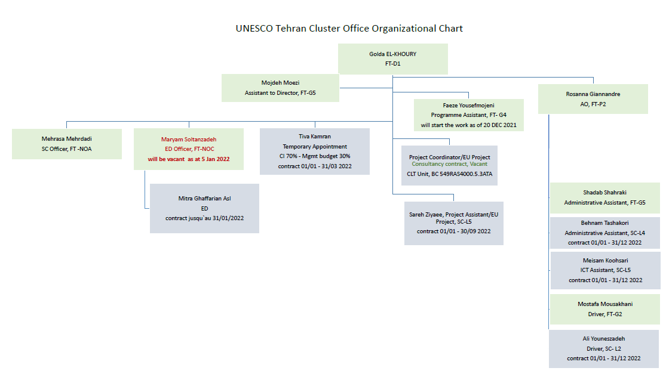

* *Clear job descriptions. What are the core functions of the key employees?*
* Needs to be requested from HRM.
* *Is there a succession plan for key positions and measures taken to develop identified people for future roles?*
* N/A
* *Performance assessments for the past biennium (or 2 years according to the new performance management policy)*
* Needs to be checked from HRM.
* *Focal points for the audit*

The following persons are key focal points for the remote audit of UNESCO Teheran Office:

|  |  |  |  |  |  |
| --- | --- | --- | --- | --- | --- |
| **Family Name** | **First Name** | **Contract Type** | **Sector**  **/Service** | **Job Title** | **Grade** |
| Cvetoski | Cvetan | Fixed | PAX | Former Officer in charge | P5 |
| Giannandre Karam | Rosanna | Fixed | FU/THE | Administrative Officer | P2 |
|  |  |  |  |  |  |
|  |  |  |  |  |  |

## Accountability framework and delegation of authority

* *Framework*
* The former Officer in Charge has signed the “Accountability for achieving UNESCO’s objectives and delivering value for money” disclosure with the Chief Financial Officer on **XX XXX XX**. As HoO, he is committed to safeguard the assets of the Office, comply policies and financial regulations, maintain reliable financial and performance information, and maintain an effective system of internal control **(to be requested from Mekdes)**.
* *Bank signatory rights from BFM/TRS*
* Approval rights from DUO Role Management show adequate segregation of duties between certifying and approving officers, as well as bank signatory. However, the AO is not yet part of bank signatory. Further, two Programme Officers i.e., one NO-A and one NO-C, have unlimited signatory approval rights raising concerns. The audit will follow-up on these exceptions.

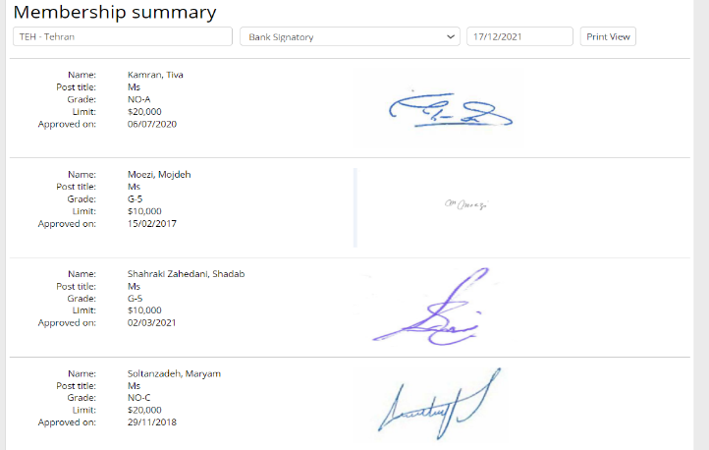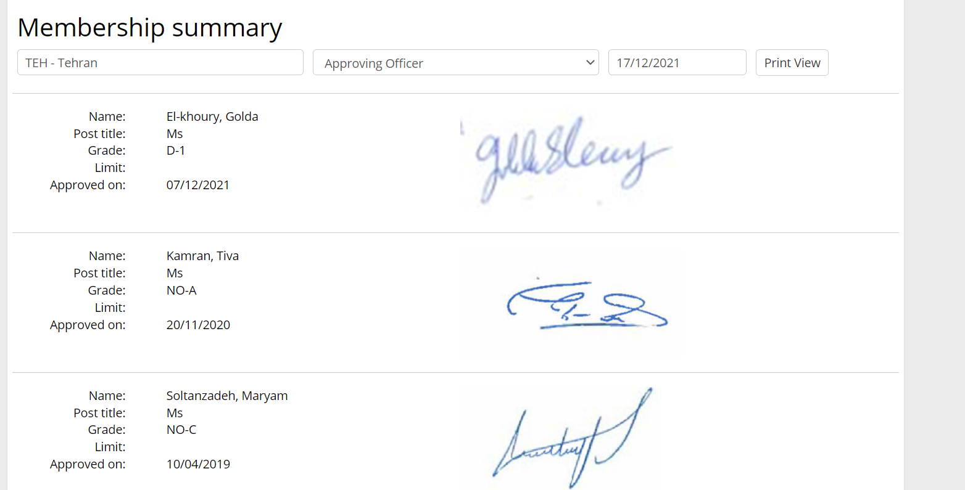

Due to the sanctions, the Tehran Office does not avail the equivalent services that other UNESCO fields offices avail from their local banks. These restrictions also bring practical problems:

* Direct bank transfers from outside of Iran such as UNESCO HQ cannot be performed. This impairs cash management operations in US dollar or euro. Cash is replenished to the office through unconventional means i.e., UNESCO HQ sends cash to the local UNDP office through the PROSPER system and then UNDP disburses the cash to the local UNESCO bank of the UCTO in local currency. Staff visiting HQ have also carried cash directly for running expenses of the office.
* Staff salary are paid separately for international and local staff. International staff receives the US dollar salaries from UNDP via cheque while local staff receive their salaries from UNDP via bank transfer.
* The use of UNDP mechanisms are complex, costly (each transaction costs US $ 50) and often the payments including salaries are delayed.
* The Iranian government is also unable to pay its assessed contributions to UNESCO and has outstanding arrears.
* Donors often shy away from UNESCO as voluntary contributions cannot be made through foreign banks into Iran.
* **The latest bank signatory letter to be obtained from Anssi if existent**

* *Segregation of duties risks, if any?*
* Review of data **shows inadequate segregation** of duties in the certifying and approving role for the creation of contracts in DUO-CMT (SAP), i.e. in 2020 - 2021 one admin assistant and a programme staff performed a supervisor approval 38 and 10 times respectively. It should be also noted that the AO was already appointed and operational in 2021. A substantive sample of procurement contracts between 2019 and 2021 will be tested during fieldwork to ensure adequate segregation of duties for payment.

|  |  |  |  |  |
| --- | --- | --- | --- | --- |
| HistoAction | Approved |  |  |  |
|  |  |  |  |  |
| **2019** | **Approving Officer (Director) Approval** | **Certifying Officer Approval** | **Supervisor Approval** | **Grand Total** |
| Cvetovski | 88 |  | 84 | 172 |
| Kamran (NO-A in CI) | 4 |  | 2 | 6 |
| Soltanzadeh (NO-C ED) | 39 |  | 37 | 76 |
| Shahraki Zahedani (Admin Assistant) |  | 45 | 38 | 83 |
| Yonten (former AO) |  | 88 | 2 | 90 |
| **Grand Total** | **131** | **133** | **163** | **427** |

|  |  |  |  |  |
| --- | --- | --- | --- | --- |
| **2020** | **Approving Officer (Director) Approval** | **Certifying Officer Approval** | **Supervisor Approval** | **Grand Total** |
| Cvetovski | 64 |  | 58 | 122 |
| Giannandre |  | 6 |  | 6 |
| Soltanzadeh (NO-C ED) | 2 |  | 9 | 11 |
| Shahraki Zahedani (Admin Assistant) |  | 51 | 10 | 61 |
| Yonten (former AO) |  | 9 |  | 9 |
| **Grand Total** | **66** | **66** | **77** | **209** |

|  |  |  |  |  |
| --- | --- | --- | --- | --- |
| **2021** | **Approving Officer (Director) Approval** | **Certifying Officer Approval** | **Supervisor Approval** | **Grand Total** |
| Cvetovski | 81 |  | 63 | 144 |
| Giannandre |  | 81 | 2 | 83 |
| Soltanzadeh (NO-C ED) | 1 |  | 7 | 8 |
| Shahraki Zahedani (Admin Assistant) |  | 2 | 30 | 32 |
| **Grand Total** | **82** | **83** | **102** | **267** |

## Ethical conduct

* *Uptake of the mandatory ethics training*
* The Ethics Office undertook a mission (in person) to the Office in June 2016. During the mission, training on Ethics and Anti-Harassment was provided to colleagues in Tehran Office. Further, Ethics and Anti-Harassment should be renewed every three years.

The table below shows the status of uptake of ethics training in Tehran Office. 85% of staff (11 out of 13) completed Ethics training and only 62% (8 out of 13) Anti-Harassment.

|  |  |  |  |  |  |  |
| --- | --- | --- | --- | --- | --- | --- |
| **Last name** | **First name** | **Last training** | **Ethics** | **Anti-Harassment** | **E-learning module** | **PSEA E-learning** |
| GHAFFARIAN ASL | Mitra | 2021 |  |  | 13/09/2021 |  |
| EL-KHOURY | Golda | 2019 | 25/06/2019 | 25/06/2019 |  |  |
| KAMRAN | Tiva | 2020 | 30/06/2016 | 30/06/2016 | 28/10/2020 | 18/07/2021 |
| KARAM GIANNANDRE | Rosanna | 2020 | 31/05/2017 |  | 10/08/2020 | 01/06/2021 |
| KOOHSARI | Meisam | 2016 | 30/06/2016 | 30/06/2016 |  | 11/08/2021 |
| MEHRDADI | Mehrasa | 2020 |  |  | 20/08/2020 | 06/10/2020 |
| MOEZI | Mojdeh | 2020 | 30/06/2016 | 30/06/2016 | 18/08/2020 | 25/07/2021 |
| MOUSAKHANI | Mostafa | 2020 | 30/06/2016 | 30/06/2016 | 29/09/2020 |  |
| SHAHRAKI ZAHEDANI | Shadab | 2020 | 30/06/2016 | 30/06/2016 | 30/08/2020 | 22/06/2021 |
| SOLTANZADEH | Maryam | 2021 |  |  | 27/06/2021 |  |
| TASHAKORI | Behnam | 2020 |  |  | 17/08/2020 | 01/06/2021 |
| YOUNESZADEH | Ali | 2016 | 30/06/2016 | 30/06/2016 |  |  |
| ZIYAEE | Sareh | 2021 |  |  | 17/08/2021 |  |

* *Any ethical issues directly affecting the audited area (sector, field office, programme, institute, etc.)*
* The main concerns raised with Ethics Office revolved around a perception of inequality by local staff vis-a-vis internationals with (staff and consultants). Part of the concerns had a direct link to the differences in remuneration, as well as a sense of unequal treatment. Further, the Ethics office also reported that one International Staff felt that the office control environment was not normal. For example, the entry to the office was restricted due to national customs. Similarly, during the pandemic, when the Officer in Charge was not in place, a national staff was performing duties beyond her remit. These duties included supervisory approvals, negotiations with National authorities etc., The audit will examine if these tasks were performed at the behest and knowledge of the OIC and HQ.
* The AO reported to IOS that she faced a number of challenges upon her arrival to Iran. She had made a formal compliant with the Ethics in 2021 insinuating that she was being pressured and harassed to follow a number of unconventional ways of working such as
  + As a foreign national, not permitted to visit the office in odd hours
  + Delayed payments in installation grants
  + Unable to buy her own internet service
  + Using cash cards under the guarantee of local staff

None of these informal reports resulted in formal complaints.

* *Corruption index of a country in the case of a field office or institute audit*

In 2020, Iran ranks 149 out 182 in Transparency international index indicating lack of transparency and the corruption perception index is 25 indicating high corruption.

***Corruption Index.*** Transparency international[1] index ranks Iran as 149/198 in the Corruption Perception Index (CPI) 2020. The score for Iran is ***25*** on a scale of 0 (very corrupt) to 100 (very clean). The country falls in Western Asia, a region that makes little progress in the fight against corruption. One of the reasons is difficult situation arising from the challenges of the pandemic and US embargo sanctions

|  |  |  |  |  |  |  |
| --- | --- | --- | --- | --- | --- | --- |
| **#** | **Country** | **Region** | **2020** | **2019** | **2018** | **2017** |
| 149 | Iran | Asia | 25 | 26 | 28 | 30 |

The following areas where corrupt practices could influence the Offices activities will be closely reviewed to identify instances of corrupt / fraudulent actions:

* Contracting of goods and services
* Selection and remuneration of service contractors

|  |
| --- |
| **Risk Management** |

Determine how the sector, field office, programme, institute, etc. proactively identifies, assess, monitor and report risks to higher levels e.g. Programme Oversight Committee (POC), ADM/COM, EXB, etc.

## Results of the Control Self-Assessment

|  |  |  |
| --- | --- | --- |
| Functional Area | Self-Assessment (2020) | IOS Comments |
| Strategic framework, risk, and control environment | Globally under control | Might need improvement since the strategic framework of the Office is weak (based on initial observations) |
| Programme Management | Might need improvement since programme mgt is weak (based on initial observations) |
| Financial Control | Might need improvement as there is a high risk of fraud/money laundering due to embargo (based on initial observations) |
| Procurement and contracting | Might need improvement as inconsistencies in SoD are observed |
| Human Resources Management | Might need improvement as there has been a long absence of OIC, abolition of fixed term program posts with incumbents |
| Travel Management | As travel has been substantial low due to the pandemic, there may not be material risks arising from deviations in policy |

## Medium and high residual risks from the risk register as of 2018

The **risk register was last updated in November 2018. IOS notes that there was no consideration of operational risks in areas such as procurement, HR related risks or physical security.**

|  |  |  |  |
| --- | --- | --- | --- |
| **Risk description** | **Risk rating** | **Mitigating control** | **Implementation date** |
| Complex and evolving political context may lead to a shift in government priorities which may result in UNESCO having to cancel or re-programme some of its activities | Critical | * Hold meetings with the National Commission * Jointly assess the political context in the UNCT * Discuss with donors the evolving context * Develop realistic C/5 workplans and have contingency plans * Closely track project implementation and expenditure rates * Exert maximum diligence (safe soundbytes) with DIR approval by Director * Keep FSC informed of evolving political context | On-going |
| Volatile and deteriorating economic context may affect funds mobilization and financial operations which may reduce implementation capacity | Critical | * Hold meetings with government counterparts * Jointly assess the economic situation and cashflow matters in the UNCT * Keep BFM informed on the evolving cashflow situation and find temporary solutions ( * Use other field offices and other UN agencies to disburse DSA, etc. * Develop realistic resource mobilization strategy * Develop workplans that fully utilize partnerships * Revise and where necessary re-programme and re-budget workplans * Sensitize programme sectors at Hqs regarding the funding needs of the office * Consult staff on how their work and motivation is affected by the situation * Assess and respond to training needs of staff | On-going |

## Medium and high residual risks from the fraud risk assessment.

**N/A. The fraud risk assessment was not done in Tehran Office.**

|  |  |  |  |
| --- | --- | --- | --- |
| **Risk description** | **Risk rating** | **Mitigating control** | **Implementation date** |
|  |  |  |  |
|  |  |  |  |

|  |
| --- |
| **Control Activities** |

## Flowcharts with clearly marked key controls and potential risks (received from the AO)

**Process 1 – Creating vendors**

* Before entering into a contract with a vendor, UNESCO must ensure that the vendor is eligible for the award of UNESCO business and has the capacity to perform the contract satisfactorily, so the vendor creation is one step behind the contract which the vendor shall be validated in the system. The process for completing the vendor request in the UNESCO vendor management system normally will be taken 7-14 days. The vendor is requested to provide below required documents:¬For Persons/Individuals:

a) A fully completed vendor form (as attached) b) Identification document(s): •Copy of an official identification document; (Identity card, Passport etc. containing the following information: Name(s), Date of birth, place and country of birth, Nationality), acronym and abbreviated names are no longer accepted. c)A bank statement/letter from the vendor containing below information• bank name, account holder name, account number, branch name, branch ID, IBAN number

*For Company or Organization:*

a)A fully completed vendor form (as attached)b)Official company or organization registration document (in both Persian and English languages) c)A bank statement/ letter from the vendor containing below information• bank name, account holder name, account number, branch name, branch ID, IBAN (Sheba) number

NB 1: The name on the registration document should be the same of the one in the account holder name in the bank statement/letter.

NB 2: The requester for the vendor creation has to ensure that the proposed vendor is not subject to UN or EU sanctions.

**Process 2 – Contracting**

* Role Management in establishment of contracts for implementing planned and approved programmes/projects and payment process:

Programme Units:

* To be requested by; Programme Officers and or Programme Assistants if any;
* To be supervised by Director/OIC of the office or Alternate approving Officer in the absence of Director;
* To be certified by AO and or AA in the absence of AO;
* To be approved by Director/OIC of the office or Alternate approving Officer in the absence of Director;
* Monitoring the work Assignment by Programme Officer (owner of the contract);
* Approving the well-delivery of the work/services by the owner of the contract;
* Authorising the processing of the payment by Director/OIC of the office or Alternate approving Officer in the absence of Director;
* Checking the supporting documents and deliverables by AO and or AA in the absence of AO;
* Uploading supporting documents in DUO (since NOV 2020) and SES creation by the owner of contract, and;
* MIRO creation by AO and or AA in the absence of AO.

Administration Unit:

* To be requested by; AA-L4 or ICT- To be supervised by AA-G5 (during the absence of AA, Director or alternate approving officer played this roll);
* To be certified by AO and or AA in the absence of AO;
* Monitoring the work Assignment by AA;
* Approving the well-delivery of the work/services/goods by AO, the owner of the contract;
* Uploading supporting documents in DUO (since NOV 2020) by AA;-SES creation by AO, the owner of contract:
* MIRO creation by AA.

Processing payments through UNDP:

* Creating PROSPER request for the payments through UNDP CO by AA-G5;
* Certifying the PROSPER request by the AO;
* Authoring the PROSPER request by BFM;
* Following up on the payment transfer with UNDP by AA-G5;
* Filing by AA-L4.

Processing payments through UNESCO bank accounts:

* Posting outgoing payments by AA-L4;
* Issuing checks and instruction letter by AA-G5;
* Collecting two signatures of the bank signatory members on the check and letter by G5;
* Completing the formalities in the bank by drivers or AA-G5;
* Filling by AA-L4.

Note: The office safe is in AA-G5’s room of for keeping the important documents as well as check books. The AA-G5 has access to the safe key and in the absence of AA, the key will be delivered to AO. The door of AA-G5 room is always locked. A video call will also be used for verification of petty cash. It should be also noted that the AO does not have access to the safe.

**Process 3 – consultants’ mission**

* The documents to approve the missions should be provided at least two weeks before the date of departure. Although included in the contract, a mission can take place only if the Manual Travel Order (Form AM 15-2) is signed by the AO (certified), the Director of the Office (approved) and the consultant (accepted).

BEFORE the mission please:

* Prepare a DETAILED AGENDA to be agreed with the Office and the Third Party Having a very detailed agenda is a must for the correct calculation of the portion to be covered by the Organization. The planification of the mission is to be agreed with the Office and the eventual third party.
* PLEASE NOTE that the VISA request should be sent to MFA at the very beginning of the preparation of the mission as the process may take more than the standard two weeks.
* Calculate the COST OF THE MISSION as per the UNESCO standard, budget availability and considering the portions eventually covered by outside sources (see the details below): ATK, DSA, TF, OTHER COSTS INVOLVED
* Copy of UNESCO`s quotations
* Copy of the ATK cost from the consultant
* Copy of VISA costs (if any) and/or exit fee (for Iranians only)
* Vaccination costs (if compulsory to get the VISA)
* Other costs if compulsory for the mission.
* PLEASE NOTE that the UNESCO Manual provides specific rates as a ceiling. Nevertheless, as the missions of a consultant should be paid as a lumpsum, there is possibility to mitigate the cost according to the availability of the budget. A clear calculation is provided below under COMPLIMENTARY NOTES, but the responsible officer can “negociate” the costs with the consultant.

3 AMEND THE CONTRACT upon review and clearance of the AO and approval of the Director

* Upload all the background documents provided as justification of the cost
* Upload the approved detailed agenda
* UNDSS clearance granted for the whole period of the mission (if several cities are covered, need for the clearance in each city) – the clearance should be based on the routing provided in the quotation approved by AO.

4 Creation of the TRAVEL ORDER to be signed by all parties (AO, Director, and traveller) Form AM-15-2 available in DUO

* The contractor is allowed to purchase his own ticket
* Upon submission of the invoice together with the payment claim, the responsible officer can request the advance payment for the reimbursement of the ATK

Please make the formal arrangements for:

* A hotel reservation(s) according to the cities of the mission
* B local transportation during the mission
* C keep exchanges with the counterpart for the smooth running of the mission

**Process 4 – environmental practices in the Office**

* The Office is committed to reduce use of electricity by energy-saving lamps and monitor detectors.
* In terms of water usage, irrigation of green space takes place only once per day in the morning. Also purifiers are used.
* With regard to waste, separate trash bins for recyclable and non-recyclable waste are used in the Office. Waste is collected by the complex three times per week for recycling or disposal.

## Key policies and documented procedures relevant to the audited area

## IT support and key systems

Vis-à-vis generic email accounts, Tehran Office never created generic accounts for short assignment staff, here is the list of generic accounts in office and their usage purposes:

* [**tehran@unesco.org**](mailto:tehran@unesco.org)(for general office communications and it is administered by Assistant Director)
* [jobvacancy-teh@unesco.org](mailto:jobvacancy-teh@unesco.org)(for job vacancies)

Generally, for staff coming to office regardless of duration of their work, if email account was needed, it was created especially for them and deleted upon their departure.

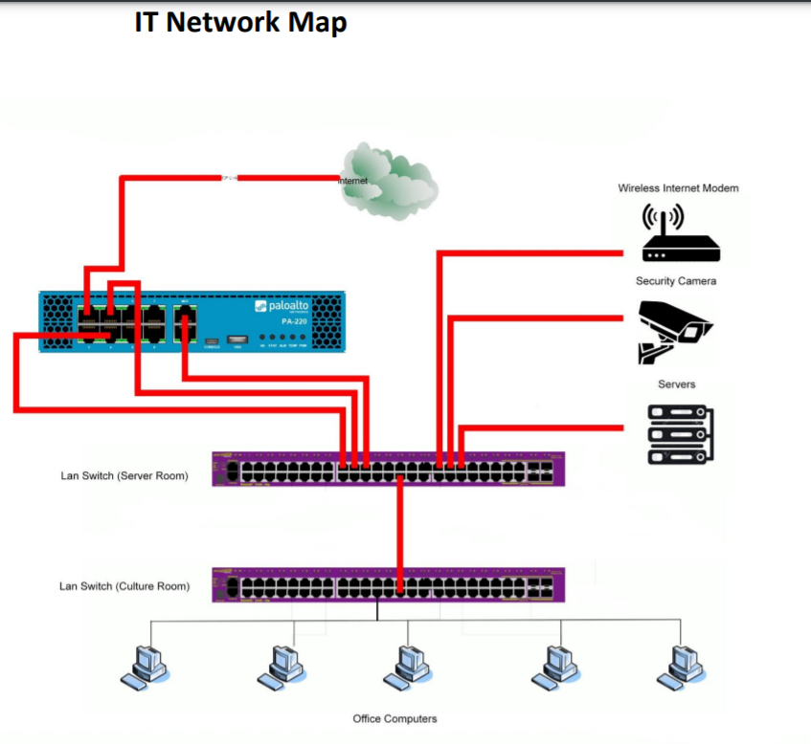

## Operational budget of the sector, field office, programme, institute and breakdown

Programmatic activities (RP and ExB) are presented below in a table along with a staffing situation:

|  |  |  |  |  |  |  |  |  |
| --- | --- | --- | --- | --- | --- | --- | --- | --- |
| **Programme Funds allocated to Tehran Office** | **2020 - 2021 (40C/5)** | **2020 - 2021 (40C/5)** | **2020 - 2021 (40C/5)** | **Staff standard costs (40C/5)** | **Number of Fixed Term Posts (40C/5)** | | | |
| **Programme Sector** | **Total (RP)** | **Total (XB)** | **Total (RP & XB)** |  | **P** | **GS** | **NOP** |
| **Source** | **YFM1 report** | **YPS8 report** |  | **40 C5 RP Standard costs** |  |  |  |
| FSC - Field Office Running Costs | 259 635 |  | 259 635 | 884 000 | 2 | 3 |  |
| SC – Natural Sciences | 130 800 |  | 130 800 | 87 000 |  |  | 1 |
| ED – Education | 56 765 | 81 821 | 138 586 | 130 000 |  |  | 1 |
| CI – Communication and Information | 40 000 |  | 40 000 | 87 000 |  |  | 1 |
| CLT – Culture | 6 180 | 653 496 | 659 676 |  |  |  |  |
| **Total** | **493 380** | **735 317** | **1 228 697** | **1 188 000** | **2** | **3** | **3** |

The Programme and staff costs ratio of the Teheran Office in comparison with other UNESCO offices:

|  |  |
| --- | --- |
| **Office** | **Ratio XB/RP** |
| Dhaka | 0,89 |
| Mexico | 2,53 |
| Juba | 1,60 |
| Kathmandu | 7,64 |
| Tehran | 1,49 |

Staff costs, notably for administration personnel, are high in comparison with programme staff and activities. Further, it should be noted that the costs of P-5 were considered for 40 C/5 and they will increase for 41 C/5 as the Director at D-1 has recently took up the role. A NOA post in CI is abolished within 41 C/5, however, the costs incurred are relatively low, i.e. US$ 87,000 per biennium.

Tehran office has implemented activities mainly in Education and Culture during the audit period in the following projects:

* 201IRA1000 (ED) - Promoting Inclusive and Equitable Quality Education in the Islamic Republic of Iran, the overall budget US$ 181,778, 2017-2019, UNICEF – donor, contributing agency
* 201IRA1001(ED) - Promoting Inclusive and Equitable Quality Education in the Islamic Republic of Iran – 2, the overall budget US$ 107,210, 2019-2022, UNICEF – donor, contributing agency
* 549RAS4000 (CLT) - Silk Roads Heritage Corridors in Afghanistan, Central Asia and Iran - International Dimension of the European Year of Cultural Heritage, a decentralized project from Almaty Office, the overall budget for Tehran Office US$ 1,456,473, 2018-2023, Donor – European Union.

The ED project (201IRA1001) is expected to be completed by April 2022 and CLT project (549RAS4000) will by September 2022. Currently, there no projects in the pipeline.

From the discussion with OIC a.i. and PAX, IOS noted an unfruitful framework agreement between UNESCO and Turkmenistan for US$ 5M signed by the former DG in 2015. The trust Fund was supposed to be for programme activities in CLT and ED. Despite several attempts of the Director of Tehran Office, BSP and OIC, they did not manage to launch the agreement and the funds did not come in.

In terms of Office expenditures, the Office spent US$ 1M for the past four years.

The table below demonstrates top vendors in terms of payments:

|  |  |
| --- | --- |
| **Vendor Name** | **Sum of Ordered Amount, (USD)** |
| International Institute of Earthqua | 80 738,8 |
| Barin Pendar Trading & Service Co . | 69 856,5 |
| Negin Sepehr Saman Co. | 63 581,1 |
| THOMAS Frederic Georges Pierre | 52 080,0 |
| Kakh Hadish Pars Engineering & | 44 827,1 |
| RCUWM | 38 901,1 |
| Special education organization | 35 076,6 |
| LOBATO DE LA FUENTE Saray | 31 715,4 |
| ICQHS INTERNATIONAL CENTER ON QANAT | 29 312,6 |
| SALIS Sabrina Maria | 28 156,0 |
| RAAD REHABILITAION GOODWILL COMPLEX | 26 327,8 |
| IRANIAN NATIONAL COMMISSION FOR | 26 145,5 |
| Allameh Tabataba'i University | 25 118,4 |
| Others with payments less than 25K | 469 664 |
| **Grand Total** | **1 021 501** |

The table below presents expenditures in $US of Tehran Office by type and per year:

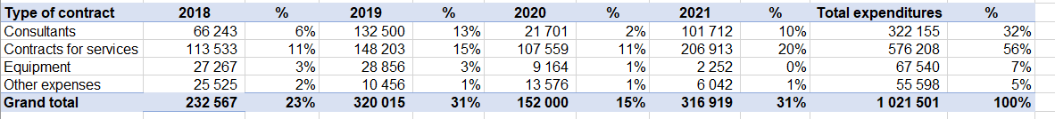

## Other statistical information e.g., from DUO, SAP

* ***Office inventory:*** As of XXX, the Office has XX inventory items amounting to the total net book value of USD XXX. During the audit period, there have not been any significant acquisitions **(to be requested from BFM)**
* **Overdue unliquidated obligations** as of XX September 2021, there XX open items from **Fund** **Reservations** totalling US $XXX of which XXX items totalling US$XXX which are due for more than 6 months. These relate to utilities and field staff operating costs.

There are X items aged over 6 months totalling US$XXX as shown in the table below. The largest item of $XXXXX relates ….

The audit team will follow-up with the Administrative Unit on the above ULOS.

**(to be requested from BFM)**

* ***Travel – Office Missions:*** during the audit period, staff from Tehran Office undertook 65 missions for the total amount of US$ 110,888. The costliest mission was the one of the OIC in 2020 as it included the part of DSA (US$ 20,696). The extended mission was planned to ensure OIC role between 02/01/2020 and 03/07/2020. DSA for half-year amounted to US$ 20,056. The audit will include a sample of missions in the audit fieldwork programme.

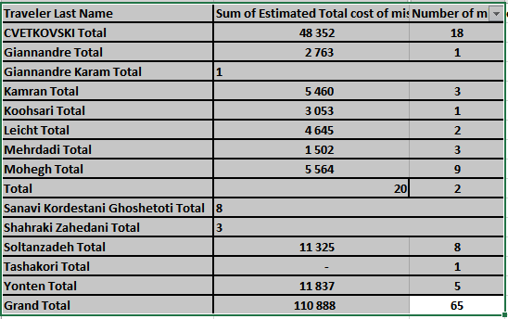

|  |
| --- |
| **Information and Communication** |

Explain the kind and sources of reports used in the sector, field office, programme, institute, etc. and indicate whether there are any expectations to report internally and externally.

* ****External reports and target audience, including any feedback from the audience****
* ****Social media reports for any positive or negative press about the programme/projects:****
* ****Media/branding strategy and activities for visibility**** 
  + *Websites, journals, portals, newsletters, publications, etc*.

|  |
| --- |
| **Prior Reports by Assurance Providers** |

Key issues and proposed recommendations (limit to high and medium risks) from assurance providers (AP). Ensure all APs have been considered, these include internal audit (AUD), JIU evaluation (EVA), external audit (EXA), MOPAN, etc. as a minimum.

|  |  |  |  |  |
| --- | --- | --- | --- | --- |
| **Recommendation number and name of audit** | **Type of AP i.e. AUD, JIU, EVA, EXA, MOPAN** | **Summary of the condition and root cause** | **Summary of the recommendation** | **Status of implementation (in-progress, closed, risk-accepted)** |
| N/A |  |  |  |  |
|  |  |  |  |  |
|  |  |  |  |  |

|  |
| --- |
| **Donor requirements** |

Brief highlight of the donor requirements in terms of:

****Main donors and total funding for a biennium****

|  |  |  |  |  |
| --- | --- | --- | --- | --- |
| **Project code** | **Name of donor** | **Total funding for a biennium** | **Sector** | **Three key donor requirements (those that can lead to termination of projects if not adhered to)** |
| 201IRA1001 (Promoting Inclusive and Equitable Quality Education in the Islamic Republic of Iran – 2) | UNICEF | US$ 107,210 | ED | Narrative reporting must be submitted following the completion of each activity/event;  Financial report must be submitted in the end of the project |
| 549RAS4000 (Silk Roads Heritage Corridors in Afghanistan, Central Asia and Iran - International Dimension of the European Year of Cultural Heritage) | EU | US$ 4,646,382 | CLT | N/A since the project is centrally managed by Almaty Office; the budget of US$ 1,456,473 was decentralized to Tehran Office |

**Results of donor inspections/spot checks/monitoring exercises and progress towards resolution of areas of improvement**

**PARTNERSHIPS**

UNESCO Tehran Cluster Office closely co-operates with the relevant government authorities of the four cluster countries of I.R. of Afghanistan, I.R. of Iran, Pakistan and Turkmenistan, UN and UNESCO offices in the region. UTCO builds upon this wide network of partners, inclusive of governmental authorities, academic and research institutions, training institutes, civil society, NGOs, the private sector and international experts.

Category 2 Centers (6) in Iran are as follows:

* Regional Research Centre on Oceanography for West Asia
* Regional Research Centre for Safeguarding Intangible Cultural Heritage in West and Central Asia
* The Regional Centre on Urban Water Management
* Iranian Research Center for the Silk Road (IRCSR), Shahid Beheshti University in Tehran
* Isfahan Regional Center for Technology Incubators and Science Park Development
* The International Center on Qanats and Historic Hydraulic Structures in Yazd

UNITWIN Networks are not present in Iran.

There are 16 UNESCO Chairs hosted in different universities of Iran.

|  |
| --- |
| **Preliminary Control Weaknesses** |

* Lack of consistent office leadership

The Office has seen five changes in the leadership in the past five years. There hasn’t been a Director appointed since July 2018. Since then, OIC has been appointed for short periods with interruptions. From March 2020 to November 2021, the OIC was operating from Paris. The new Head of Office awaits government clearance pending which she is remotely managing the office from Rabat.

* Deficient cluster role of the office

With an incomplete staffing resources, the office fails to provide support to the four cluster countries.

* Inadequate project/program portfolio

Without an updated UNESCO country strategy (UCS) complemented by a resource mobilization strategy, the project portfolio is currently very low with no future projects in the pipeline. This is partially due to absence of program staff to support implementation as well as to engage in discussions with partners and potential donors.

* Cash transactions restrictions

The US embargo has put in place sanctions since 2018. Therefore, the Tehran Office does not avail the equivalent services that other UNESCO fields offices avail from their local banks. For example:

* Cash operations in US dollar or euro are severely impaired.
* International staff receive their US dollar salaries from UNDP via cheque while local staff receive their salaries from UNDP via bank transfer.
* The use of UNDP mechanisms are complex, costly (each transaction costs US $ 50) and often the payments including salaries are delayed.
* The Iranian government is also unable to pay its assessed contributions to UNESCO and has outstanding arrears.
* Donors often shy away from UNESCO as voluntary contributions cannot be made through foreign banks into Iran.
* Segregation of duties

IOS was informed of instances where the segregation of duties in contracting was lacking. The underlying reasons are currently unknown and will be explored during the field tests, the controls will be reviewed, and deviations will be assessed.

* Excessive signatory rights

IOS notes that two office staff (NOA – CI and NOC- ED) have unlimited approval rights for commitments. Normally, this privilege is only with the Head of the Office. The underlying reasons are currently unknown and will be explored during the field tests, the controls will be reviewed, and deviations will be assessed.

|  |
| --- |
| **Report - Audit Rationale, Scope and Objective** |

****Audit rationale****

In line with the 2021 Internal Audit Plan, IOS conducted an audit of  the UNESCO Teheran Office . Moreover, the following questions also supported conducting the audit engagement.

1. What is the cluster role of the Office? Without Culture, SHS and CI staff (the latter being abolished in 41C/5, how does the office perform its cluster role?
2. How are we operating there?

* UNDP is not subject to any national economic sanction regime, however UNDP’s banking partners are and they have responsibility to enforce all relevant economic sanctions regulations issued by their regulators.



* UNDP has immunity from OFAC but UNESCO does not as USA is not a member state. How does UNESCO pay transactions in USD? is there anybody other than staff touching the USD?
* With the restriction of $, there is a risk of exposure for UNESCO to operate there
* Payment of salaries through UNDP. How do int staff open a bank account? How do int staff receive salary? how do they operate without a bank ac.
* In facilitating cash to international staff, does someone play a go between? Is there anyone drawing power or getting personal benefit?

1. Is the AO or any international staff able to perform the work independently?

****Audit objective****

The objective of the audit is to provide assurance on the effectiveness of internal controls, governance and risk management processes of the Teheran Office. Furthermore, review the efficiency, effectiveness, and economy of the Office’s operations (including programme management, financial controls, procurement, travel, human resources management, security, IT, and general administration). These audit objectives will be assessed in the context of COVID-19 and how the office has responded to it. Due to travel restrictions as a result of COVID-19, the audit can only provide limited assurance as no physical inspections will be conducted. IOS/AUD is considering partnerships with local auditors to conduct physical inspections, if deemed necessary.

****Audit rationale****

The audit rational is provided below:

* At the September 2021 (212 Executive Board), the DG presented an updated overall strategy for UNESCO’s field presence in line with the draft Medium-Term Strategy for 2022-2029 (41/C4). This strategy took into account the specificities and needs of each region and subregion and developments of the United Nations reform. The audit findings will help in further shaping the future role of the Teheran office as a regional or national office.
* In April 2021, The Executive Board[2] requested the Director-General to ensure that the Internal Oversight Service (IOS) risk-based audit work plan is fully funded under document 41 C/5 and that an adequate level of resources is made available with the goal of achieving complete field office coverage in a 5-year cycle.
* DIR/IOS elaborated a strategy to cover the audit coverage of the UNESCO’s field network for the period 2022-2026. In this strategy, the office was identified as a high-risk entity. Further, IOS decided to re-assess Tehran Office as medium-risk due to low materiality of operations.
* The office was last audited in 2008 and a new head of office has been appointed in December 2021. The complexity of cash management arising from the sanctions raises concerns of operational risks. The audit will provide an objective assessment of the office functioning for the incoming director.

****Audit scope and period****

The audit will cover activities and transactions undertaken from 1 January 2019 to 31 October 2021.

The audit is planned as a remote exercise in the following areas:

* + Overall governance of the Office (including objective setting, planning, and risk management),
  + Programme management,
  + Financial control,
  + Contracting and procurement,
  + Travel,
  + Human resources and
  + General administration​

****Audit methodology****

The audit will be performed in accordance with the *International Standards for the Professional Practice of Internal Auditing* and OS audit manual.

The audit will assess the functioning of internal controls within the defined scope in order to identify major risks to the achievement of the Teheran Cluster Office objectives. Action plans will be agreed to strengthen risk management and controls, and to improve operations where warranted.

The audit will be based on surveys, interviews, data analysis, documentation review, etc. The audit team will select the sampling techniques such as judgemental, statistical, representative, etc. to ensure the sampling approach remains relevant to the test objectives.

As part of the initial risk assessment, Interviews held in the planning phase

* PAX (Magda Landry)
* BFM (Mekdes)
* Officer in Charge Teheran Office (Cvetan Cvetkovski)
* Director, UNESCO Teheran Office (Golda El-Khoury)
* ED/EO was not available
* Administrative Officer and assistant (Rosanna and Shadab)
* Science EO
* Culture EO
* SHS EO
* CI EO
* Cedric Bourgeois - Head of Investigation, IOS
* Mary Mone - Chief of Security (field cooperation)

****Key milestones****

IOS will conduct the audit of the Tehran Office per these timelines:

| **Milestone** | **Planned date** | **Targets** |
| --- | --- | --- |
| Notification letter | 19 November 2021 |  |
| Initial Risk Assessment | 21 December 2021 |  |
| TORs shared with audit client | 19 November 2021 |  |
| Entrance Meeting | 25 November 2021 |  |
| End of planning/ Start Fieldwork | 21 December 2021 |  |
| Exit Meeting | 15 February 2022 |  |
| End of fieldwork | 15 February 2022 | One week after the exit meeting |
| Draft report | 28 February 2022 | Two weeks after the exit |
| Client comments and agreed  management action plans | 7 March 2022 | Two weeks after receiving the draft report |
| Final report | 15 March 2022 | One week after receipt of final comments and action plans |
| Release TM+ assignment |  | One month following the issuance of the final report |

****Audit resources****

The budgeted days for this assignment are 74 days as follows:

|  |  |  |  |  |  |
| --- | --- | --- | --- | --- | --- |
| **Activity/ Persons-days** | **Planning** | **Fieldwork** | **Draft report** | **Finalization** | **Total** |
| Head of Audit (Soriano) | 2 | 0 | 2 | 2 | 6 |
| Principal Auditor (Pise) | 5 | 12 | 10 | 5 | 32 |
| Associate Auditor (Beltyukova) | 5 | 16 | 10 | 5 | 36 |
| Total | 12 | 28 | 22 | 12 | 74 |

|  |
| --- |
| **Report - Background** |

Summarize all the information above into a background to be used for the audit report (target 3 pages)

|  |
| --- |
| **Annex 1 – Risk Matrix and Work Programme** |

The audit programme is embedded [through the following link.](https://unesco.sharepoint.com/:x:/r/sites/IOSTeam/Shared%20Documents/Audit/Internal%20Audit/Audits%20and%20other%20assignments/2021/Tehran/1.%20Planning/Tehran%20Audit%20Programme.xlsx?d=w47ee0e78ef544396beac2ecdb6969808&csf=1&web=1&e=H7Zyb0)

|  |
| --- |
| Engagement Terms of Reference(Remote Audit of the UNESCO Tehran Office) |

Terms of Reference to be shared with the audit client at the end of the audit planning phase.

****Background****

This audit was planned upon ad-hoc request.

****Audit scope and period****

The audit will cover the xxx activities from 1 January 2018 to 31 March 2020, the audit team may also review other periods if necessary. The audit is planned as a full scope exercise including the following areas:

* Overall governance of the Office (including objective setting, planning, and risk management),
* Programme management,
* Financial control,
* Contracting and procurement,
* Travel,
* Human resources and
* General administration

****Objectives****

****Audit methodology****

The audit will be performed in accordance with the *International Standards for the Professional Practice of Internal Auditing* and IOS audit manual.

The audit will assess the functioning of internal controls within the defined scope in order to identify major risks to the achievement of the UNESCO Tehran Office objectives. Agreed Management Actions (AMAs) will be mutually established to strengthen risk management and controls, and to improve operations where warranted.

The audit will be based on surveys, interviews, data analysis, documentation review, etc. The audit team will select the sampling techniques such as judgemental, statistical, representative, etc. to ensure the sampling approach remains relevant to the test objectives.

****Planned schedule****

IOS will conduct the audit of the UNESCO Teheran Office per these timelines:

| **Milestone** | **Planned date** | **Targets** |
| --- | --- | --- |
| Notification letter | 19 November 2021 |  |
| Initial Risk Assessment | 12 January 2022 |  |
| TORs shared with audit client | 14 January 2022 |  |
| Entrance Meeting | 25 November 2021 |  |
| End of planning/ Start Fieldwork | 17 January 2022 |  |
| Exit Meeting | 22 February 2022 |  |
| End of fieldwork | 22February 2022 | One week after the exit meeting |
| Draft report | 8 March 2022 | Two weeks after the exit |
| Client comments and agreed  management action plans | 22 March 2022 | Two weeks after receiving the draft report |
| Final report | 29 March 2022 | One week after receipt of final comments and action plans |
| Release TM+ assignment |  | One month following the issuance of the final report |

****Audit resources****

The audit will be carried out by Mr Sameer Pise, Principal Auditor, and Ms Anastacia Beltyukova, Associate Auditor. The fieldwork will commence on 17 January 2022.

.

1. <https://www.transparency.org/en/cpi/2019/results/ssd>
2. 211 EX/44 decision